Lab Report

**Lab 01: Routing Concepts and Static Routing**

**Subject:** Quản trị mạng và hệ thống

**Class:** NT132.N21.1

**Group Members (Group 02):**

|  |  |  |
| --- | --- | --- |
|  | **Students’s names** | **Student ID** |
| 1 | Nguyễn Trần Bảo Quốc | 21520421 |
| 2 | Nguyễn Trọng Tấn Phong | 21522460 |
| 3 | Nguyễn Thành Đăng | 21520683 |
| 4 | Trịnh Tấn Đạt | 21520714 |

|  |
| --- |
| **Self-evaluated Score** |
| **10** |

**Evaluation:**

|  |  |
| --- | --- |
| Total time spent | 1 day |
| Lab Task | • Lab Task 1.a: Phong  • Lab Task 1.b: Đạt  • Lab Task 2: Everyone  • Packet Tracer: Quốc, Đăng  • Report Writing: Quốc |
| Issues *(if any)*  + Difficulty  + Recommendations |  |

Table of Contents

**A.** Lab Task 2

1. Router and Routing concepts 2

a. What is the role of routers, switches and hubs in a network system? 2

b. What is static routing ? Briefly describe advantages and disadvantages of static routing. 2

2. Subnetting and static routing (Task 3) 2

**B.** References 6

# Lab Task

## Router and Routing concepts

### What is the role of routers, switches and hubs in a network system?

A router is a network layer device that serves 2 main functions: **Forwarding** data packet from its input port to the correct output port, and **Routing** – find the best way for packets to reach their destinations.

A switch is a data link layer device that is responsible for filtering and forwarding packets within a LAN using MAC address.

A hub forwards packets by sending them to all connected devices. Because hubs can neither filter data nor find the best path for packets, they are considered inefficient and insecure.

### What is static routing ? Briefly describe advantages and disadvantages of static routing.

Static routing is a routing method in which every route in the routers is configured manually by the admin.

Advantages: This method is not complicated, therefore cheaper router can be used for routing. It also provides better security because the admin has total control over the routes.

Disadvantages: Extremely inefficient in large networks as every route has to be manually added. The admin is required to have good knowledge of the network (in order to configure it manually).

## Subnetting and static routing (Task 3)

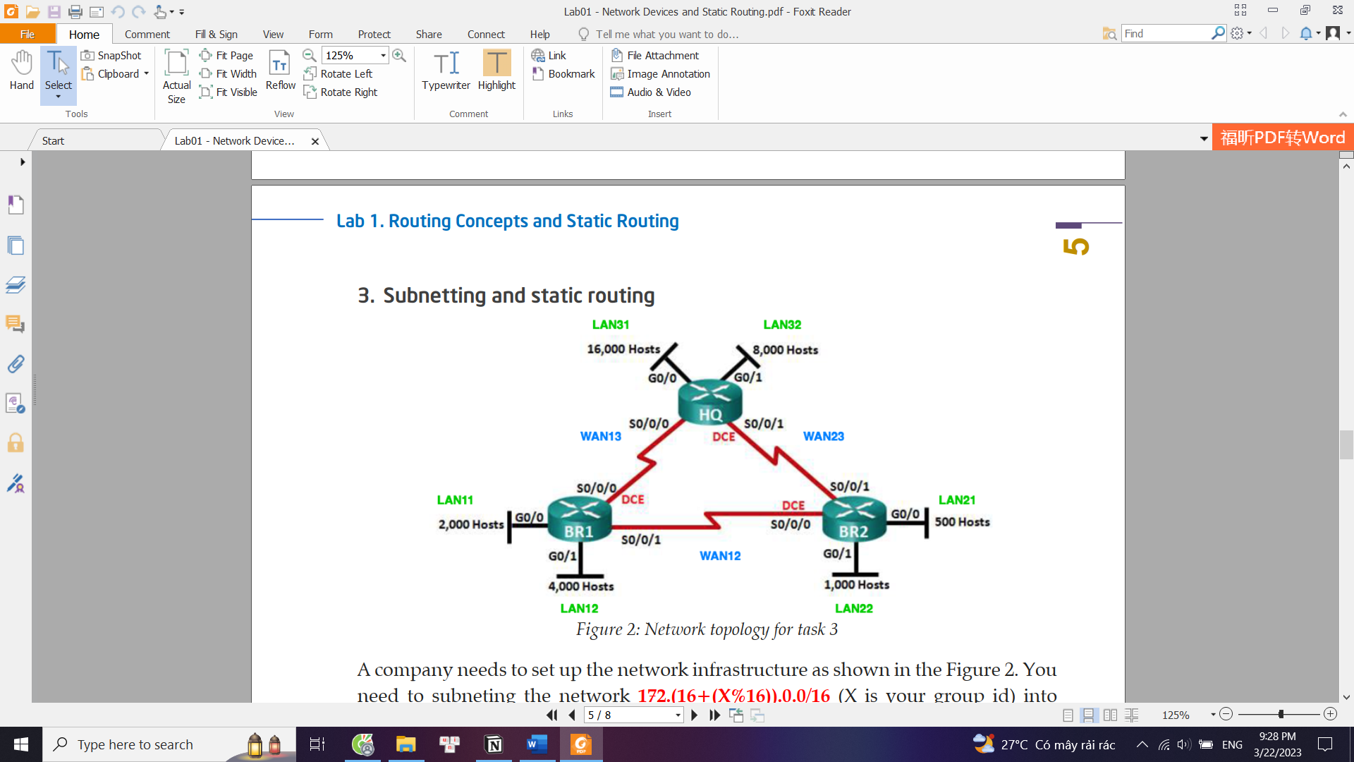

**Step 1:** Subnetting the network address 172.18.0.0/16

To do this, we sort the subnet based on number of hosts, in descending order:

LAN31 > LAN 32 > LAN 12 > LAN 11 > LAN 22 > LAN 21 > WANxx

We start with the largest subnet (LAN31), subnet 172.18.0.0/16 into smaller subnets, then assign the first one to LAN31. After that, we use the remaining subnets to subnet even further, assign one of them to the next largest subnet, then do it again.

*For example*: LAN31 has 16000 hosts.

We need 14 host bits, so the subnet mask will be /18. The result of subnetting 172.18.0.0/16 will be: 172.18.0.0/18 (1)

172.18.64.0/18 (2)

172.18.128.0/18

172.18.192.0/18

We use (1) for LAN31, then use (2) to subnet further for other subnets.

In the end, we obtain this table:

|  |  |  |  |
| --- | --- | --- | --- |
| **Subnet** | **Network Address/CIDR** | **First IP Address** | **Broadcast Address** |
| LAN11 | 172.18.112.0/21 | 172.18.112.1 | 172.18.119.255 |
| LAN12 | 172.18.96.0/20 | 172.18.96.1 | 172.18.111.255 |
| LAN21 | 172.18.124.0/23 | 172.18.124.1 | 172.18.125.255 |
| LAN22 | 172.18.120.0/22 | 172.18.120.1 | 172.18.123.255 |
| LAN31 | 172.18.0.0/18 | 172.18.0.1 | 172.18.63.255 |
| LAN32 | 172.18.64.0/19 | 172.18.64.1 | 172.18.95.255 |
| WAN12 | 172.18.126.0/30 | 172.18.126.1 | 172.18.126.3 |
| WAN13 | 172.18.126.4/30 | 172.18.126.5 | 172.18.126.7 |
| WAN23 | 172.18.126.8/30 | 172.18.126.9 | 172.18.126.11 |

**Step 2:** Assign IP addresses to router interfaces and PCs

Using the table obtained from Step 1, we can configure the IP address and default gateway as below:

|  |  |  |  |  |
| --- | --- | --- | --- | --- |
| **Device** | **Interface** | **IP Address** | **Subnet Mask** | **Default Gateway** |
| HQ | S0/1/0 | 172.18.126.5 | 255.255.255.252 |  |
| S0/1/1 | 172.18.126.9 | 255.255.255.252 |  |
| G0/0/0 | 172.18.0.1 | 255.255.192.0 |  |
| G0/0/1 | 172.18.64.1 | 255.255.224.0 |  |
| BR1 | S0/1/0 | 172.18.126.6 | 255.255.255.252 |  |
| S0/1/1 | 172.18.126.1 | 255.255.255.252 |  |
| G0/0/0 | 172.18.112.1 | 255.255.248.0 |  |
| G0/0/1 | 172.18.96.1 | 255.255.240.0 |  |
| BR2 | S0/1/0 | 172.18.126.2 | 255.255.255.252 |  |
| S0/1/1 | 172.18.126.10 | 255.255.255.252 |  |
| G0/0/0 | 172.18.124.1 | 255.255.254.0 |  |
| G0/0/1 | 172.18.120.1 | 255.255.252.0 |  |
| PC11  (LAN11) |  | 172.18.112.10 | 255.255.248.0 | 172.18.112.1 |
| PC12  (LAN12) |  | 172.18.96.10 | 255.255.240.0 | 172.18.96.1 |
| PC21  (LAN21) |  | 172.18.124.10 | 255.255.254.0 | 172.18.124.1 |
| PC22  (LAN22) |  | 172.18.120.10 | 255.255.252.0 | 172.18.120.1 |
| PC31  (LAN31) |  | 172.18.0.10 | 255.255.192.0 | 172.18.0.1 |
| PC32  (LAN32) |  | 172.18.64.10 | 255.255.224.0 | 172.18.64.1 |
| Server  (LAN31) |  | 172.18.0.20 | 255.255.192.0 | 172.18.0.1 |

**Step 3:** Cisco Packet Tracer

Now we can start configuring routers and end devices as well as the static routes in Cisco Packet Tracer, using the detailed table in Step 2.

Network Overview

Redundancy route for BR1 and BR2

# References

Information about routers, switches and hubs:

<https://www.geeksforgeeks.org/network-devices-hub-repeater-bridge-switch-router-gateways/>

Information about static routing, floating static routing and more:

<https://www.cisco.com/c/en/us/td/docs/switches/datacenter/nexus3000/sw/unicast/503_u1_2/nexus3000_unicast_config_gd_503_u1_2/l3_route.html#wp1070923>